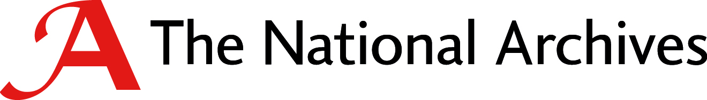
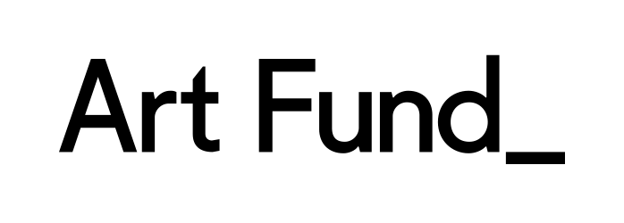
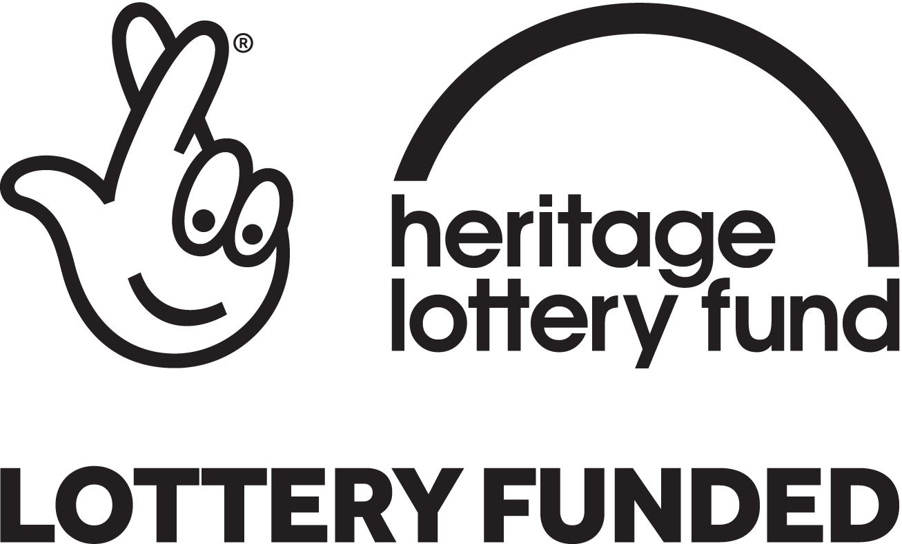
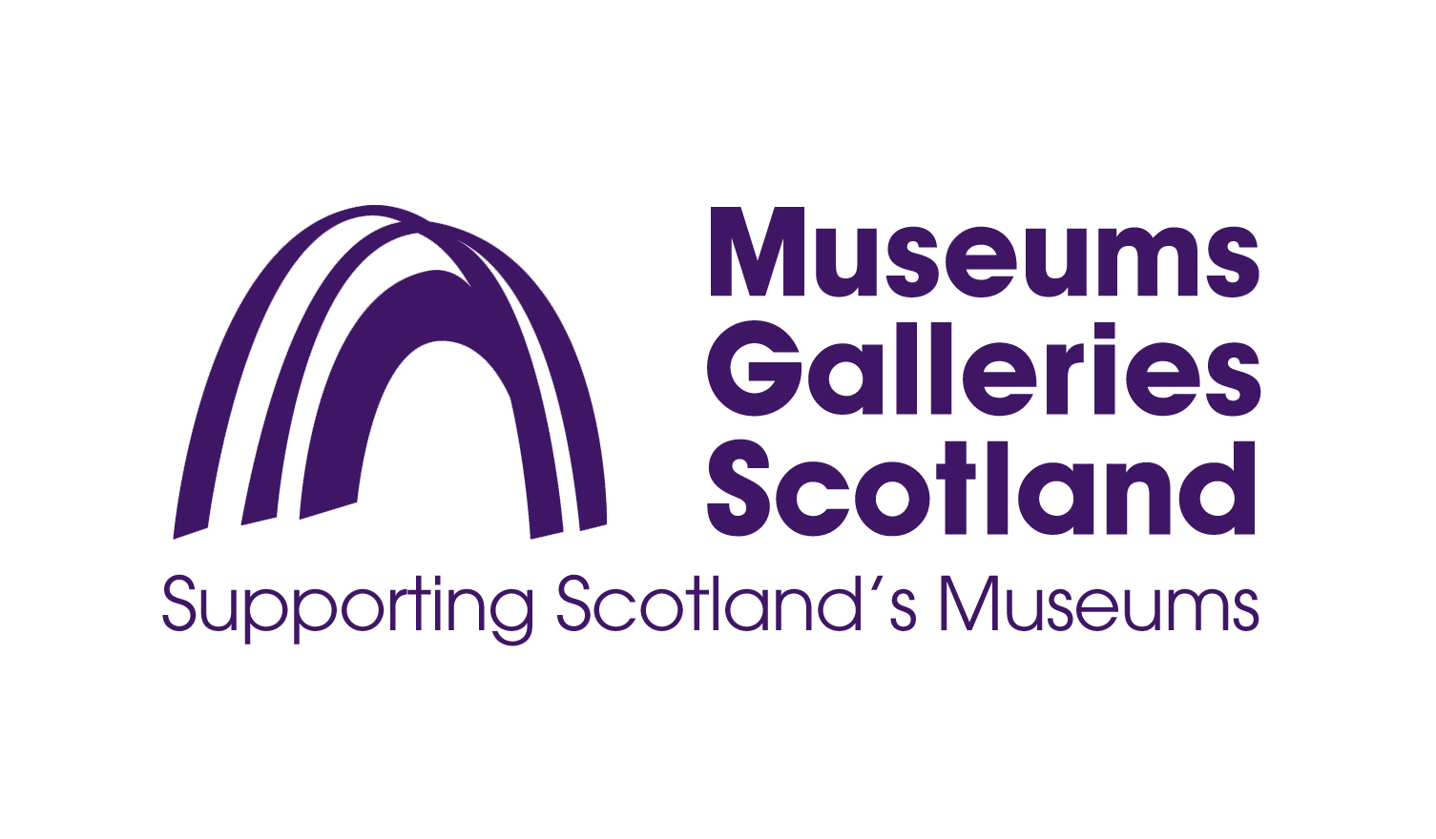
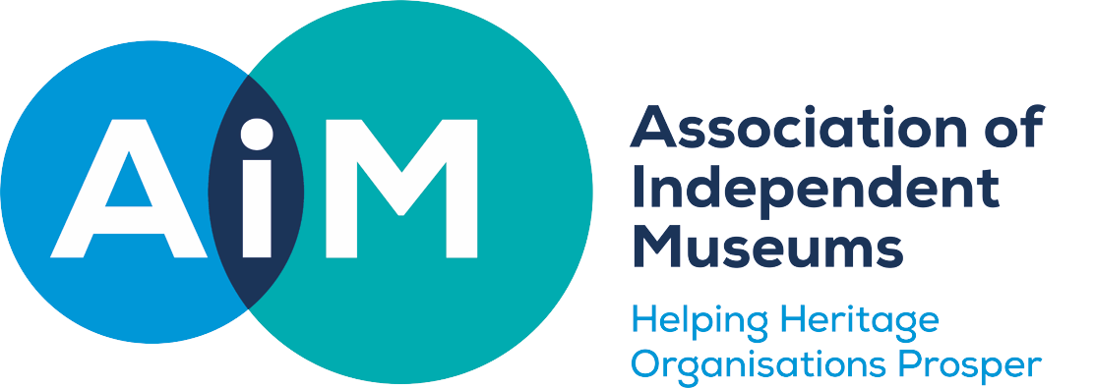
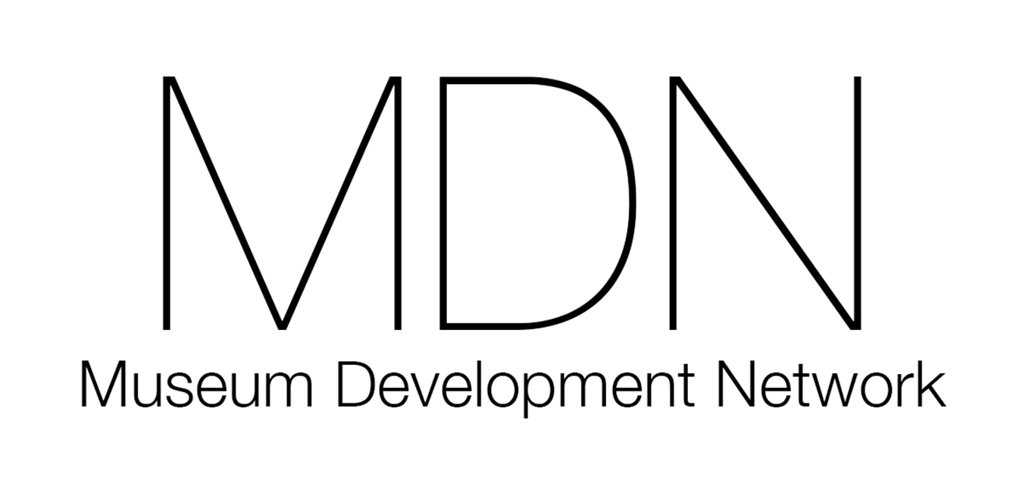
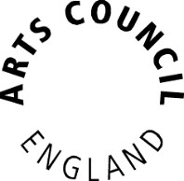
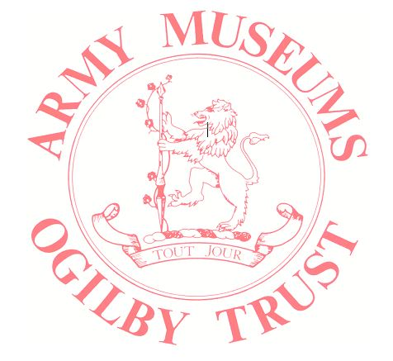
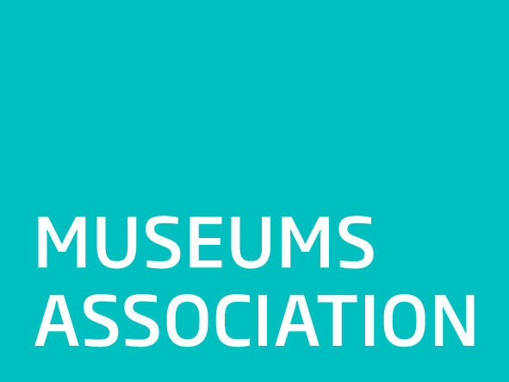
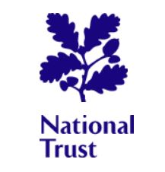
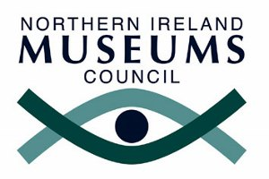
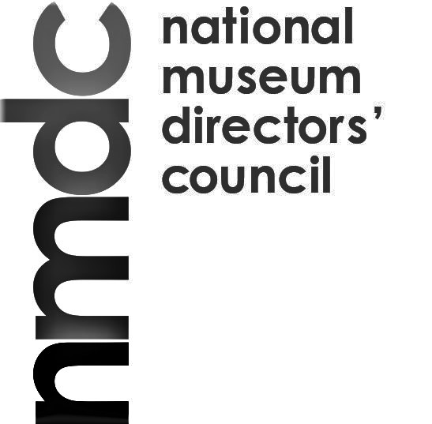
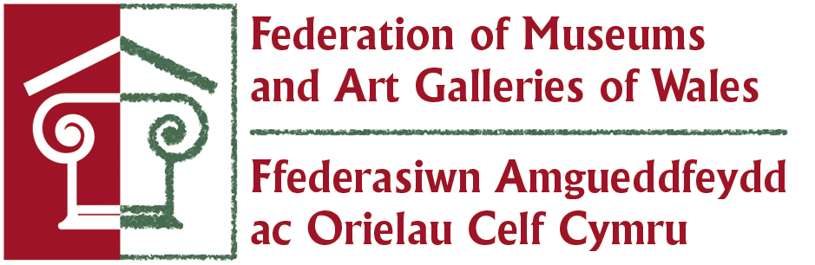

Joint statement on museums and collections at risk

Museum funders and sector bodies have agreed a co-ordinated approach in response to situations when museums or collections are at risk. This joint statement sets out this commitment.

Arts Council England; the Heritage Lottery Fund; Museums Association; Army Museums Ogilby Trust; the Association of Independent Museums; Collections Trust; English Heritage; Historic England; University Museums Group; Art Fund; National Museums Directors’ Council; National Trust; Museums Galleries Scotland; Northern Ireland Museums Council; The National Archives; the Museum Development Network and the Welsh Museums Federation will work together in offering guidance to museums which are in difficulty. In doing so, we are responding to the Mendoza Review of Museums, published in November 2017, which included the recommendation of a new protocol to shape the response to museums and collections at risk: that is, the possible loss of public access through closure of museums, or the sale or dispersal of collections or historic buildings.

The organisations supporting this statement wish to provide appropriate and timely advice in such situations, supporting governing bodies in their decision-making. However, the responsibility for the stewardship of the museum, its buildings and collections remains with the governing bodies and an effective response will depend on the willingness of an organisation to take ownership of its issues.

We urge organisations, or individuals, who have concerns about the sustainability of a museum or collection to contact the most relevant organisation, as early as possible. We commit to sharing information between relevant parties, if given permission to do so, so that we can determine who is best placed to help. We recognise that in some cases, there might be a need for confidentiality and more discreet conversations.
When approached with concerns, we commit to working in partnership. We will meet to discuss appropriate responses. Our aim will be to help ensure the public retain long-term access to the collections held for their benefit.

Our joint response will take into account the circumstances of each case, recognising that museums vary greatly in terms of the collections and buildings they manage, their users, business and governance models, scale of operation and income streams.

We recognise that it may not be possible to secure a long-term future for some museums or collections. However, we believe that the chances of a positive outcome are greatly increased if there is timely and open discussion about the situation and if all appropriate organisations are involved in giving advice and support.

